19CSE401 - Compiler Design

Lab Sheet 4

S Abhishek

AM.EN.U4CSE19147

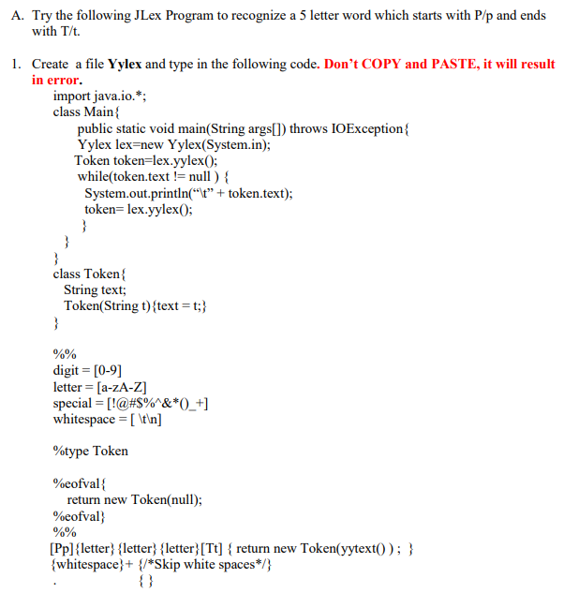

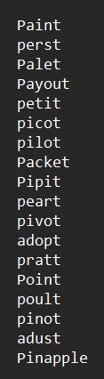

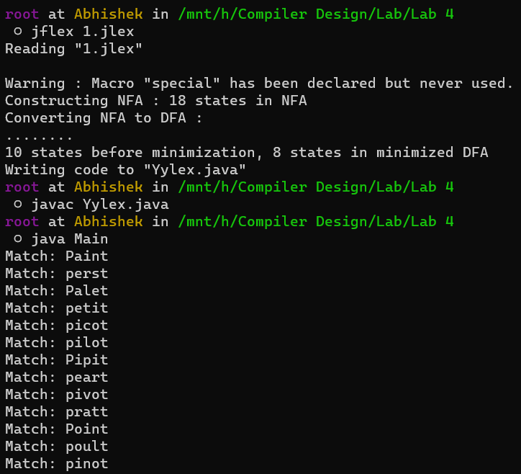

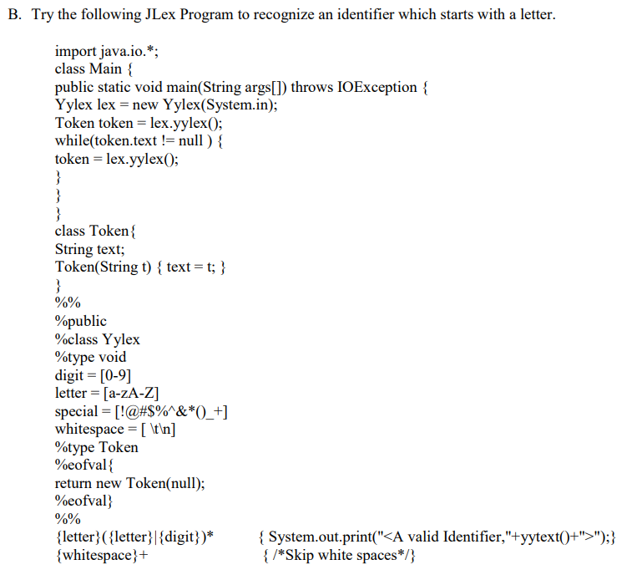

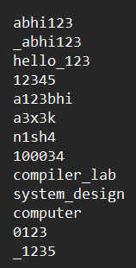

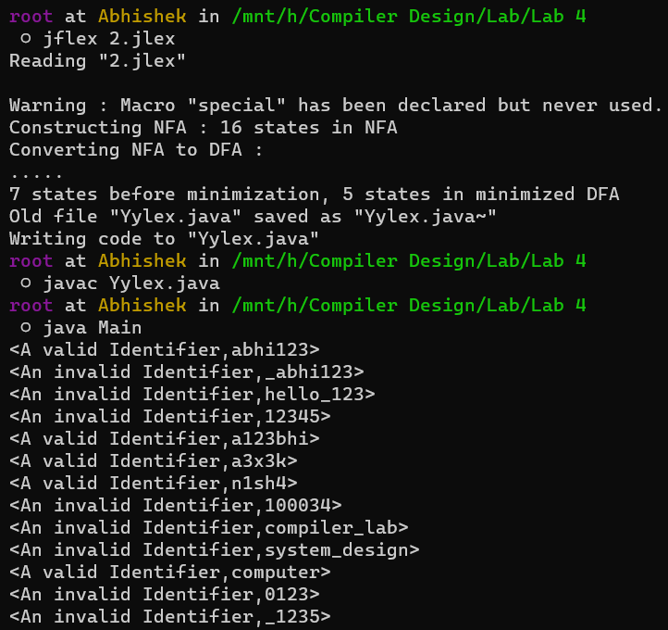

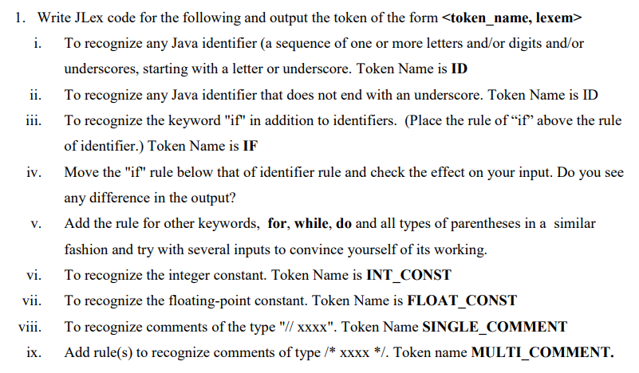

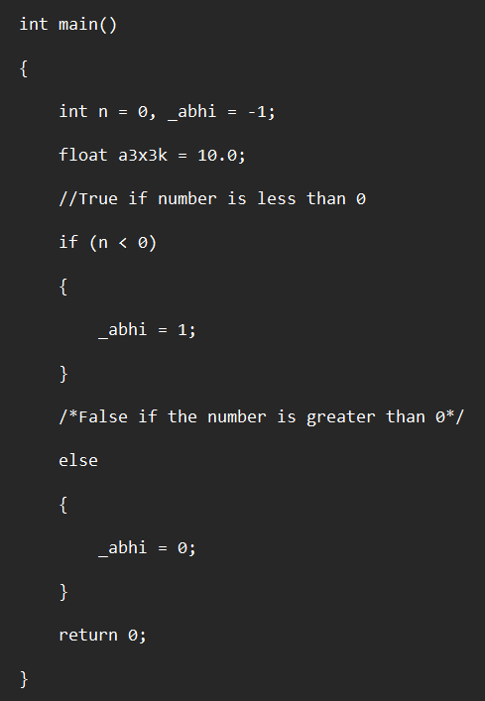

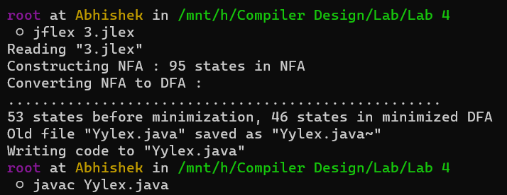

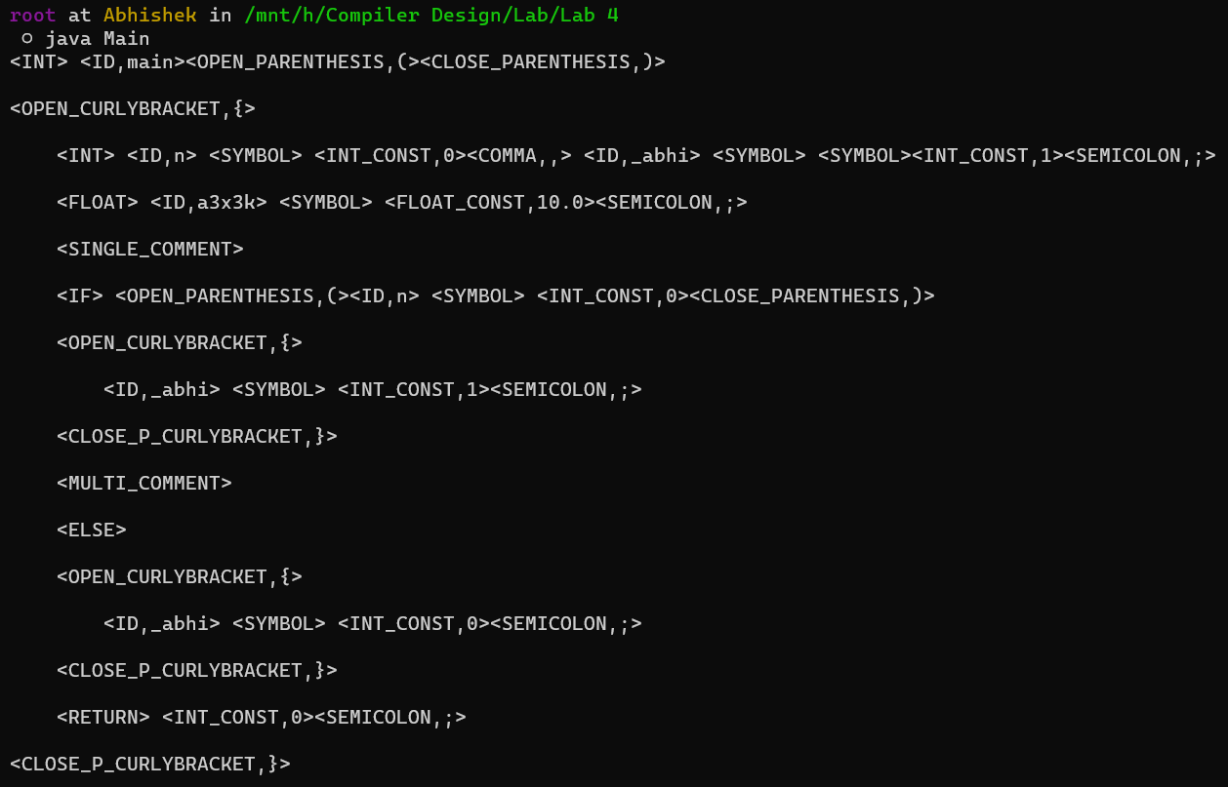

* If we move the **“If”** rule below the identifier rule then this if rule won’t be considered since the compiler encounters the **“ID”** rule first which has the similar regex expression and constrain declaration and directly proceeds without checking the following rules.
* In the image above **“If”** keyword is considered as an **“IF”** Token itself since the rule for the **“If”** is given above the identifier rule to make the compiler to encounter this **“IF”** rule first and **“ID”** rule next.
* In the image below **“If”** keyword is considered as an **“ID”** since the rule for the **“If”** is given below the identifier rule, thus the compiler encounters the **“ID”** rule first and the **“If”** rule next.

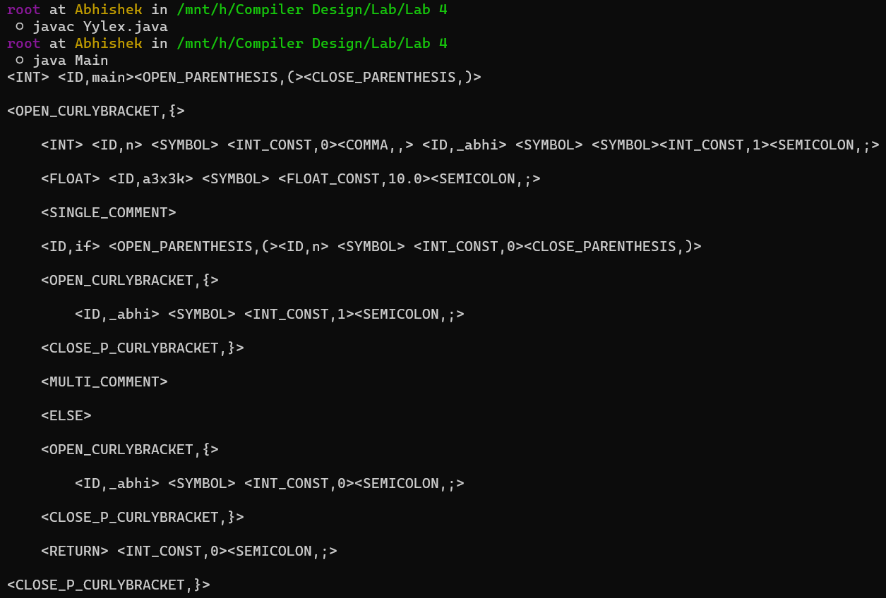

Thankyou!!